**quizApplicationangular APP Screen shots**

1.Home Page to start the quiz.

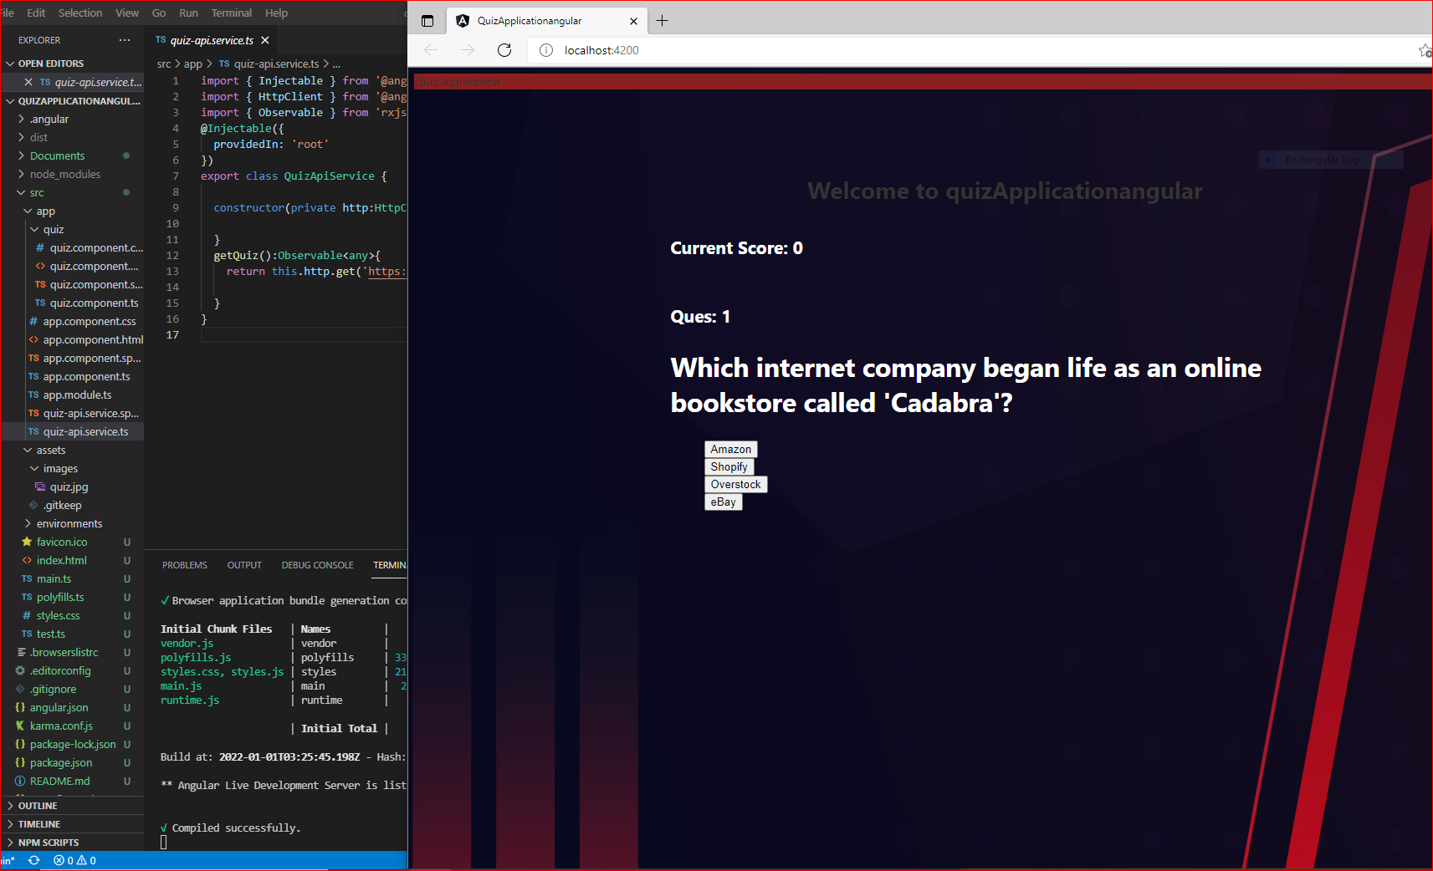

2. You can attend the quiz by click on the correct option for each question.

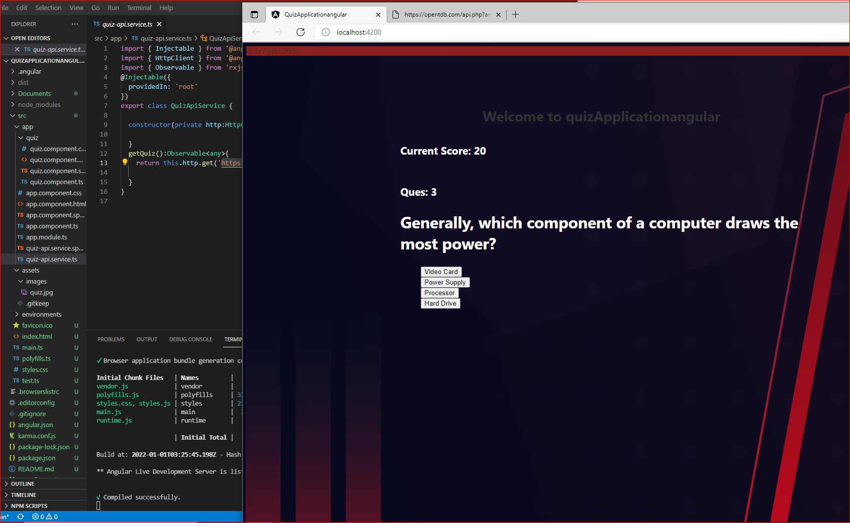

3. After answering 10 questions. Review the test and see your score.

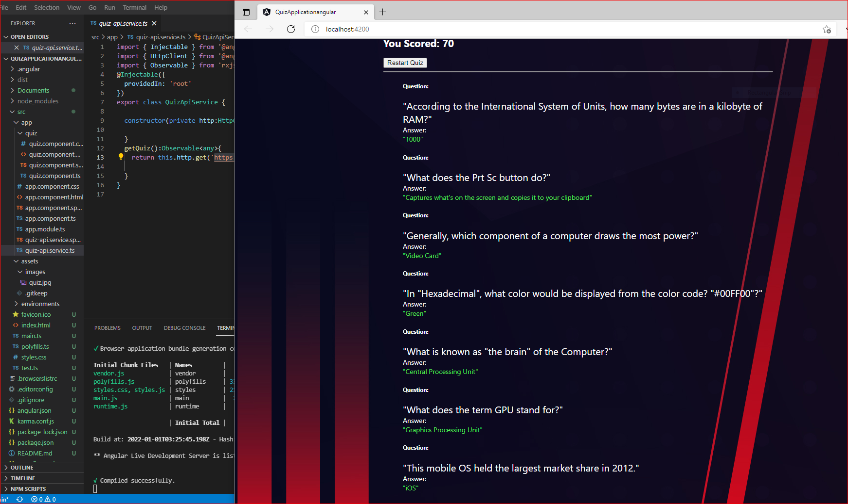

4. Click on Restart Quiz button to start the Quiz again.

